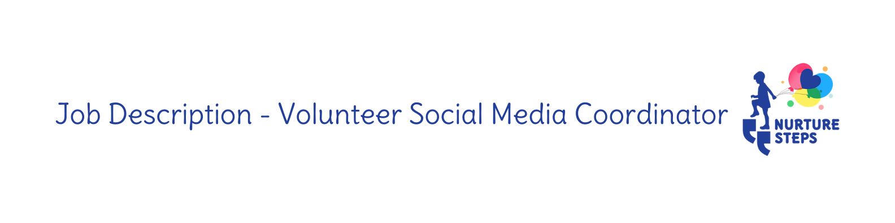
Role: Volunteer Social Media Coordinator Reports to: Marketing Director
Responsibilities: Social Media post creation and interaction

Purpose of the role:
Responsible for the creation, management and public engagement over social media platforms.

General & Key Responsibilities:
- Creating and scheduling content
- Use of established branding
- Engagement with service users and consultants over social media platforms
- Collaborating with planning and strategic tasks based on service delivery.
- Arrange and facilitate Q&A speakers on FB
- Regular meetings with Admin Assistant
- Preparing monthly reports
- Handle sensitive information and pass on to the appropriate parties.

Skills required for this Role
- Experience with Social Media Platforms
- Familiar with Canva
- Good understanding of marketing strategies
- Strategically and operationally aware.
- Enthusiasm for the message and organisations intentions
- Support aspirations and ambitions, be outward-looking and encourage high expectations.

About you
- Shares values, vision and mission of Nurture Steps
- Experience and/or understanding of disabilities relevant to the organisation
- Respectful, encouraging and supportive
- Excellent communication skills
- Enthusiastic, has an eye for detail
- Organised, self-motivated and enjoys the creation of content
- Driven by the charities’ intentions and ethos
- Close to or in Fife or Dundee

Commitment and requirements
- 10 hours per week
- Drive company forward and champion for Nurture Steps
- Contribute to strategy meetings with regard to marketing

Support
You will be given all the required guidance and support before beginning your role, including NSPCC Child Protection Training.

Record your interest
Email: info@nurturesteps.com

